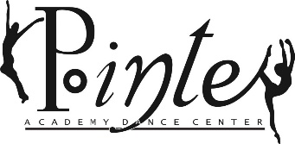

CELEBRATING 27 YEARS UNITED IN DANCE
We are magnified
Payment Policy
The Pointe Academy Dance Center allows you to pay tuition and fees in 4 convenient ways:
- Automatic credit card plan for all tuition and studio fees. Gabrielle will run your credit card on the first of the month for tuition fees and on the respective date that other studio fees are due throughout the year.
- Manually process your credit card payment using the Jackrabbit Parent Portal. All tuition fees and studio fees due dates remain the same.
- Mail your payment to:
Poitne Academy Dance Center
P.O. Box 81904
Rochester, MI 48308
Payments must be received (not postmarked) by the respective due date or a late fee will be applied.
- Cash or check payment brought to the studio on respective due dates during any day of the week.
It is required that all families have a credit card on their Jackrabbit Account, this is non-negotiable.
If tuition is not paid by the 7th of every month, a 10% late fee will be added to your account and subsequent late fees will be added each month tuition payment is not received. If studio related fees are not paid, 20 days after the charge has been posted to your jackrabbit account, a 15% late fee will be added, and subsequent late fees will be charged each month fees are not paid.
There is a $35 declined transaction fee and a $25 returned check fee if PADC receives a returned check.

I have received and the read the Pointe Academy Dance Center Payment Policies:

Name:__________________________________________

Signature:________________________________________ Date:______________

PADC Staff signature:________________________________________________Date:__________

