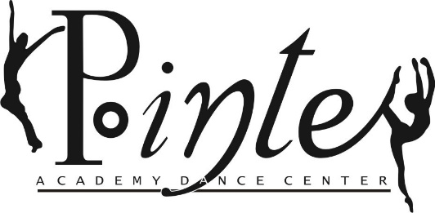
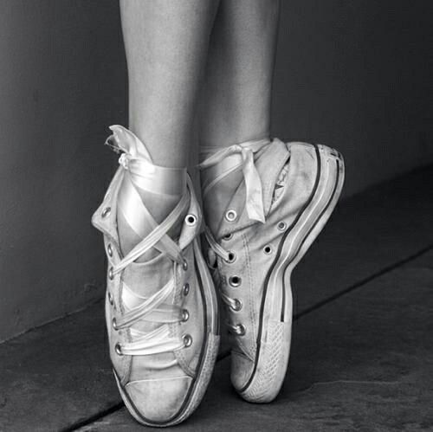

Celebrating 26 Years of Dance!
837 E. Auburn Road
(248) 852-2585

Summer Monday Ballet Technique Classes
Mark your calendar for some great ballet technique classes this summer. We welcome all students Level III, IV, V, VI, adults & alumni.
Repertory Students are required to attend at least 3 Summer Monday Ballet Technique classes.

Time: 5:30-7:00 PM
Cost: $60 for 4 classes
$80 for 6 classes
$15 for Drop in

Teachers: Mrs. MaryBeth
Mrs. Jessica
Miss Rylie

Dates:
June 25 | August 13
July 9 | August 20
July 23
July 30
*dates and teacher are subject to change

Name______________________________________ Level____
Address_____________________________________
Email___________________________________
Drop in_____ 4 Classes_____ All 6 Classes_____

