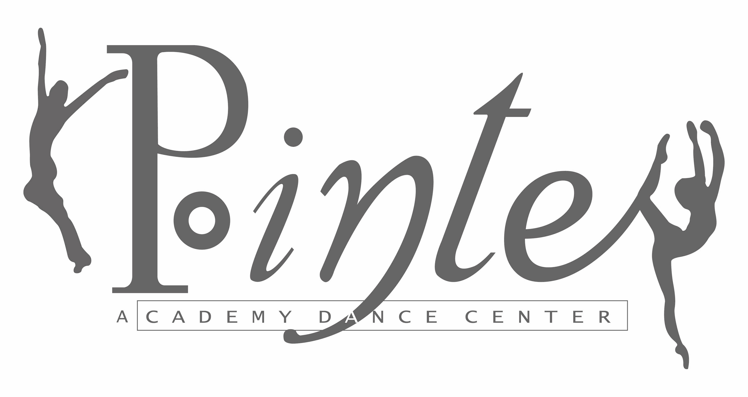
837 E. Auburn - Rochester Hills, MI 48307

Wednesdays with Judy!

This series is reserved for Alumni, Levels IV, V, VI, and Adult dancers. Enjoy an intensive workout and technique building class designed specifically for our Repertory Company, Adults and Alumni.

Join us!

When July 8, 15, 22, 29

Cost $60

Drop-in Rate $20 per class

Time 6:30 – 7:45 pm

Please email us your registration or send via U.S. mail to: Pointe Academy Dance Center
P.O. Box 81904
Rochester, MI 48308

Name

Phone

Email

NOTE: Due to Summer Festival, July 15 class will be from 7:30 – 8:45 p.m.

