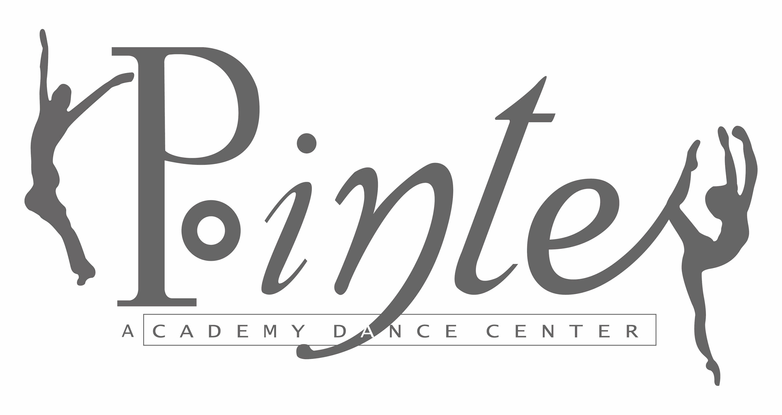
837 E. Auburn - Rochester Hills, MI 48307

Workout Wednesdays for Dancers !

This series of Master Classes is reserved for Alumni, Levels IV, V, VI, and Adult dancers. Enjoy an intensive workout and technique building class designed specifically for our Repertory Company, Adults and Alumni.
Your master class teachers will be:

July 6 | Ms. MaryBeth | Ballet, Yoga themed stretches and exercise, Relaxation/Journey
July 13* | Ms. Kara | Cardio, Squats, Push-Ups, Abs, strength exercises beyond your normal dance class...
July 20 | Ms. Gabrielle | The Latest in dance conditioning from WMU Dance Department.  (bring your Thera Band)
July 27 | Ms. Jessica | Modern “Ms. Judy” theme

Join us!
When July 6, 13, 20, 27
Cost $60 for 4 classes
Drop-in Rate $20 per class
Time 6:00 – 7:00 pm

Please email us your registration or send via U.S. mail to: Pointe Academy Dance Center
P.O. Box 81904
Rochester, MI 48308

Name

Phone

Email

*PLEASE NOTE:
Due to Summer Dance Intensive, July 13 class will be from
7:30 – 8:30 p.m.

