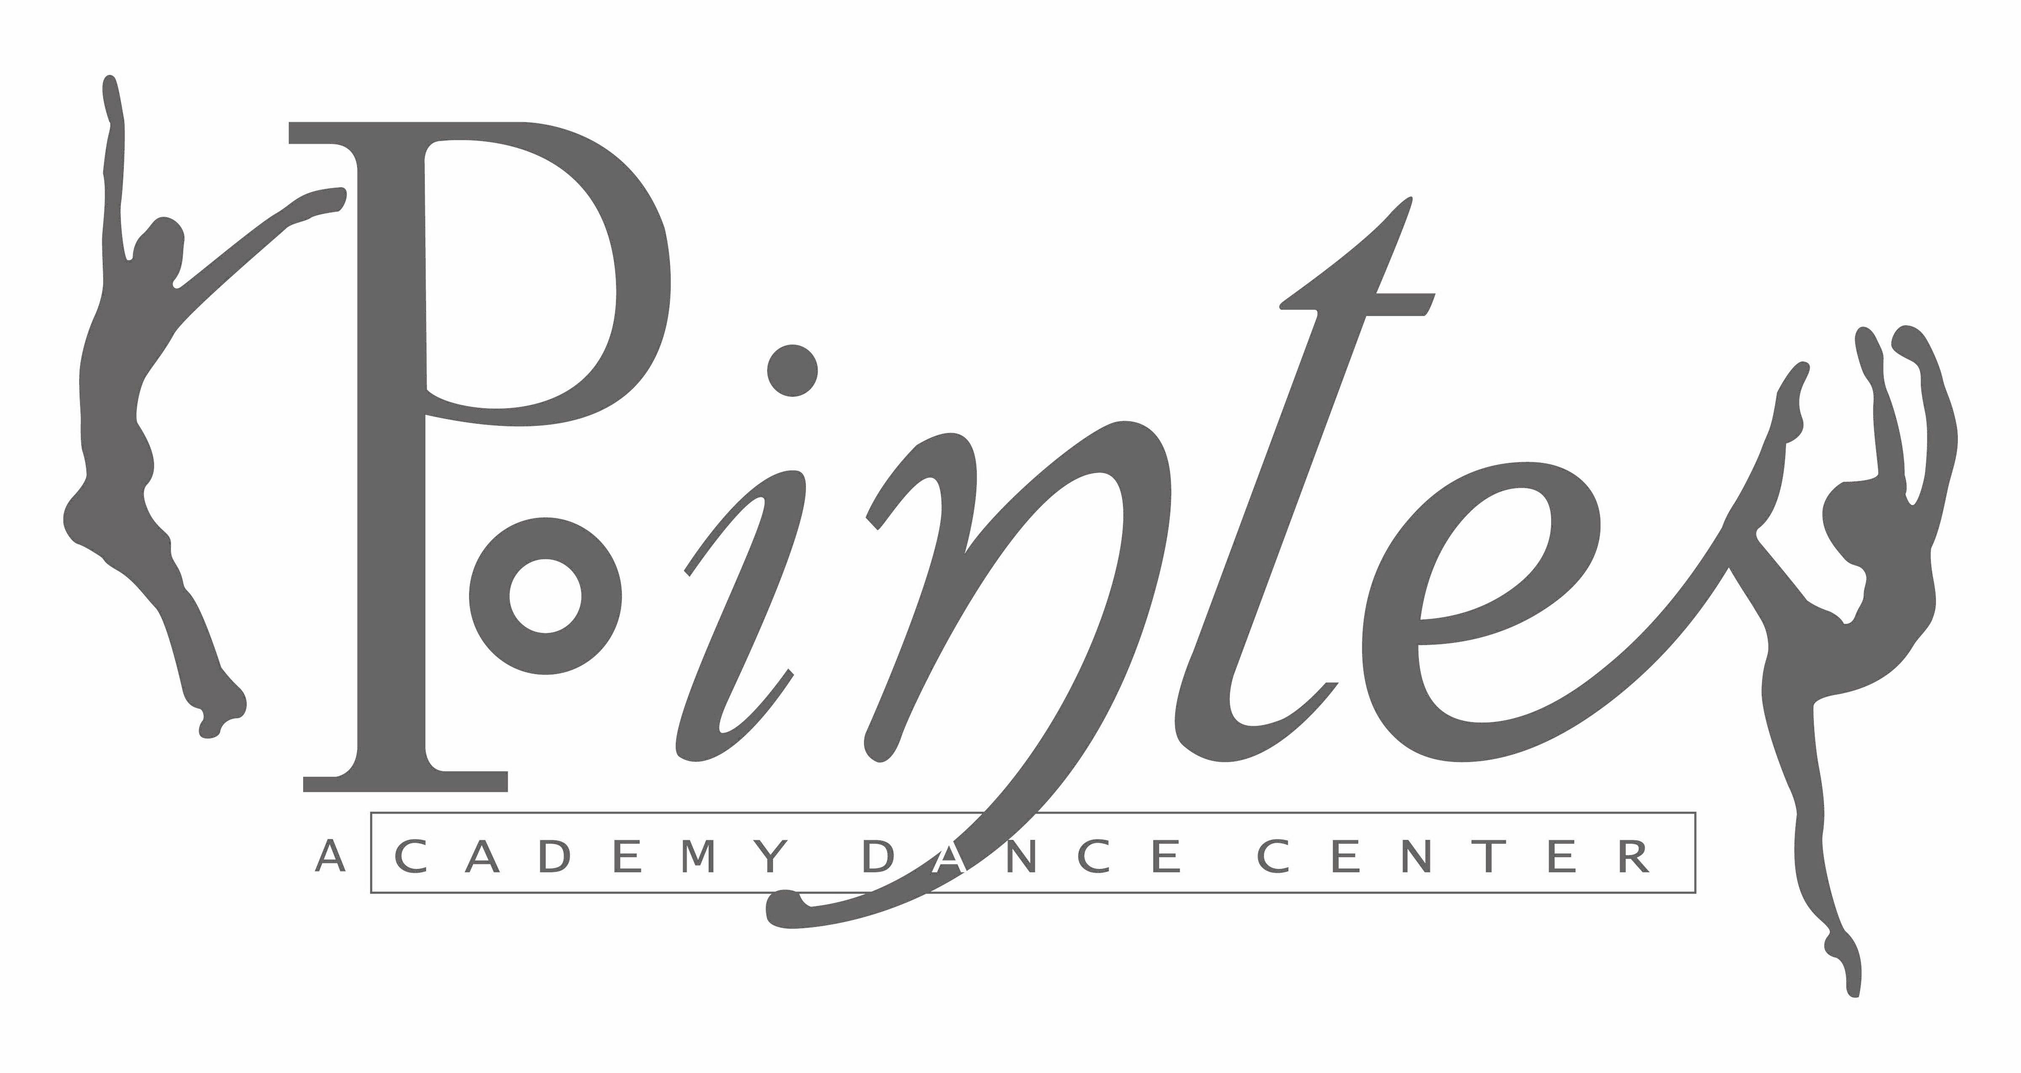

Celebrating 25 years of Dance & Family

2017-2018 CLASS SCHEDULE
 | STUDIO A |  | STUDIO B
Monday |  | Monday
4:45 – 5:30 | Pre-Pointe/Conditioning IV (10-13) REQUIRED | *4:30 – 5:30 | Ballet II (7-9)
5:30 – 6:15 | Jazz II (7-9) | 5:30 – 6:30 | Ballet IV (10-13)
6:15 – 7:15 | Modern V (14-16) | 6:30 – 7:45 | Adult Ballet (18+)
7:15 – 8:15 | Ballet V
Tuesday |  | Tuesday
4:45 – 5:30 | Tap I/Jazz I (4-7) | 4:30 – 5:15 | Pre-Dance
5:30 – 6:15 | Tap II/III (7-11) | 5:30 – 6:15 | Ballet I (4-7)
6:15 – 7:15 | Contemporary V/VI (14-18) | *6:15 – 7:15 | Ballet III (8-11)
7:15 – 8:00 | Sr. Epic V/VI (14-18) | 8:00 – 9:15 | Ballet V/VI (14-18)
Wednesday |  | Wednesday
4:30-5:15 | Jr. Epic II/III/IV
*5:15 – 6:15 | Ballet II/III (7-11) | 5:15 – 6:15 | Modern IV (10-13)
6:15 – 7:00 | Lyrical III/IV (8-14) | 6:15 – 8:15 | Ballet/ Modern VI (16-18)
7:00 – 8:00 | Jazz IV (10-13)
Thursday |  | Thursday
4:30 – 5:30 | Jr. Hip Hop II/ III/IV (7-13) | 5:30 – 6:30 | Rep Co. Ballet *REQUIRED* IV/V/VI (10-18)
5:30 – 6:30 | Jazz III (8-11) | 6:45 – 7:45 | Jazz V/VI (14-18)
6:30 – 7:15 | Tap IV (10-13) | 7:45 – 8:30 | Sr. Hip Hop V/VI (14-18)
7:30- 8:15 | Adult Tap (18+)
8:30-9:15 | Tap V/VI (14-18)
Saturday |  | Saturday
9:30 – 10:30 | Combined Ballet Technique II, III, IV, V, VI | 10:30 – 11:15 | Conditioning V, VI, Adults (12-18+)
11:30-12:30 | Choreography
* 2 classes per week recommended
(Age range – approximate)
Classes  > Ballet II & III are encouraged to take two ballet classes a week (does not include Saturday Class)  > Rep Co members are required to take all classes in package A  > Director reserves the right to adjust class placement | Teachers & schedule subject to change

