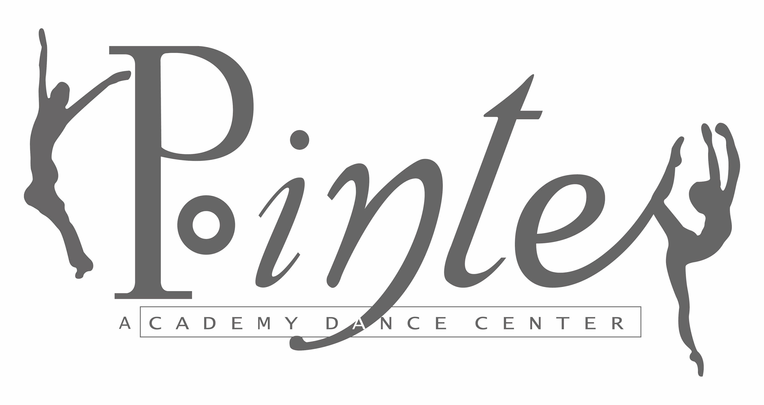

THE POINTE ACADEMY DANCE CENTER
2016-2017 CLASS SCHEDULE
 | STUDIO A |  | STUDIO B
Monday |  | Monday
5:30 – 6:00 | Tap II (7-9) | 4:30 – 5:30 | Ballet II (7-9)
6:00 – 6:30 | Jazz II (7-9) | 5:30 – 6:30 | Ballet V (14-16)
6:30 – 7:15 | Contemporary V/VI (14-18) | 6:30 – 7:30 | Adult Ballet (18 Up)
 |  | 7:30 – 8:45 | Ballet VI (16-18)
Tuesday |  | Tuesday
4:30 – 5:15 | Tap I/Jazz I (4-7) | 4:30– 5:15 | Pre-Dance (2^{1/2}-4)
5:15 – 6:15 | Tap III (8-11) | 5:15 – 6:00 | Ballet I (4-7)
7:15 – 8:00 | Tap V/VI (14-18) | *6:15– 7:15 | Ballet III (8-11)
 |  | 7:15– 8:15 | Ballet IV (12-14)
 |  | 8:00 – 9:15 | Modern VI (16-18)
Wednesday |  | Wednesday
4:30 – 5:30 | Jazz III (8-11)
*5:30- 6:30 | Ballet III (8-11) | 5:00-5:45 | Modern IV (12-14)
6:45 – 7:45 | Jazz IV (12-14) | 5:45 – 6:45 | Ballet IV (12-14)
7:45 – 8:15 | Lyrical IV (12-14) | 6:45-8:45 | Ballet/Modern V (14-16)
Thursday |  | Thursday
6:00 – 7:00 | Jazz V (14-16) | 6:00 – 7:00 | Ballet VI (16-18)
7:00 – 7:30 | Epic Dance Team IV/V/VI (12-18) | 7:30 – 8:15 | Tap IV (12-14)
7:30 – 8:00 | Lyrical V/VI (14-18)
8:00 – 9:00 | Jazz VI (16-18)
Saturday |  | Saturday
9:00 – 10:15 | Ballet Technique IV/V/VI (12-18) | 9:30 – 10:15 | Pre-Dance (3-5) Triple Threat
10:15 – 11:15 | Ballet Technique II/III (7-11) | 10:15 – 11:00 | Conditioning IV, V, VI (12-18)
 |  | 11:00 – 11:45 | Teen Hip Hop/Hip Hop IV(12-18)
 |  | 11:45 – 12:30 | Jr. Hip Hop II, III (7-11)
* 2 classes per week recommended
(Age range – approximate)
Classes  > Ballet IV students are required to take 2 ballet classes per week (does not include Saturday class).  > Ballet V & VI students are required to take 2 ballet classes per week (does not include Saturday class) and Modern.  > Jazz IV students must take 2 ballet classes.  > Jazz V & VI students are required to be in Ballet V or VI.  > Tap Repertory students (Level IV, V & VI) are required to take at least 1 ballet class. | Teachers & schedule subject to change

