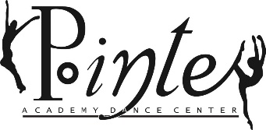
Celebrating 28 years of Dance Excellence

2020-2021 Payment Agreement

I click her to enter text agree to pay & understand that tuition payment is due on the 1st of every month, and that May & June tuition are to be paid together on May 1. I understand if my payment is not received by the 7th of the month, I will be charged a $25 late fee and $10 each week my balance remains unpaid.

I agree to pay the following fees for the 2020-2021 dance year. I understand if I do not agree to pay, my child will not be allowed to perform in the student concert.

SEPTEMBER 2020  June 2021 Student Concert Ticket (6) Deposit  PRICE TBD | NOVEMBER 2020  Dependent on students’ class  2021 student concert costume deposit  $40.00 Pre dance  $65.00 Per dance | DECEMEBER 2020  2021 Student concert DVD & Finale  PRICE TBD | FEBRUARY 2021  Dependent on students’ class  Student Concert costume Balances  PRICE TBD | APRIL 2021  Repertory Company must sell ad for $100.00 for student concert program

I understand that if my account remains unpaid for more than 30 days, my child will not be able to perform in any studio events, until the account is completely paid off.

I understand that all payments are nonrefundable and there will be no exceptions for the COVID-19 pandemic, dropped classes, scheduled holiday breaks or snow days. I also agree, to not email the studio asking for refunds or discounted prices due to any of the circumstances listed above.

I will agree and will abide by the protocol and payment policy above put in place by the Pointe Academy Dance Center.

Click or tap here to enter text. click her to enter text
Parent/Guardian Signature Date

__________________________________________ ______________
PADC Staff Witness Date

